CALL FOR PAPERS

•Cultural Production and the State•

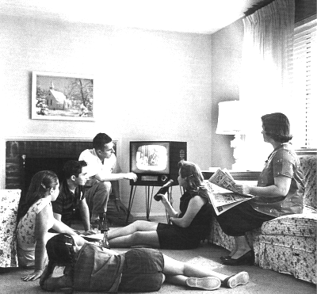
Papers are currently being accepted for the Southwest/Texas Popular Culture & American Culture Association’s Annual Conference being held in Albuquerque February 2006.

This year a new Area has been developed entitled “Cultural Production and The State.” This Area has been created to explore the ways in which cultural production reproduces and/or undermines the State.

This Area is currently seeking new and provocative papers that illustrate the critical role popular culture assumes in constructing our collective understandings of the political landscape(s) in which we live.

Abstracts are due November 15, and must be 150-250 words. Please include any technical needs.
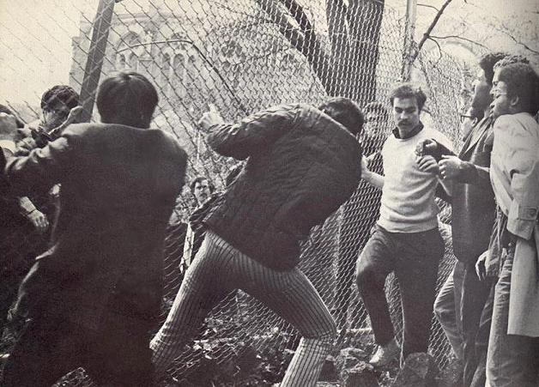

WHAT: Southwest/Texas Popular Culture/American Popular Culture Annual Conference
WHEN: April 8-11, 2006
WHERE: Hyatt Regency Albuquerque

For more information on this Area please contact Michelle Stewart at mlstewart@ucdavis.edu
For more information on the conference and other Areas please visit: http://www.h-net.org/~swpca/

ABSTRACTS ARE DUE NOVEMBER 15, 2005.

